Blockchain Assignment 13
1. Write a solidity program to Calculate the sum of all numbers from 1 to a given
number using a for loop.
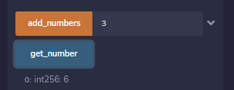
Code:
//SPDX-License-Identifier:MIT

pragma solidity ^0.8.0;

contract sum_numbers{

int256 private mynum;

function add_numbers(int256 _num) public returns (int256)
{
mynum = 0;
for(int256 i=1;i<=_num;i++)
{
mynum += i;
}
return mynum;
}

function get_number() public view returns(int256)
{
return mynum;
}
}

2. Write a solidity program to find the factorial of a given number.
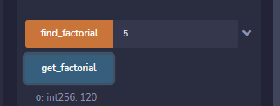

Code:
contract factorial{

int256 private myfact = 1;

function find_factorial(int256 _fact) public returns (int256)
{
if (_fact == 0)
{
return 1;
}
else
{
for (int256 i=1;i<=_fact;i++)
{
myfact = myfact * i ;
}
return myfact;
}

}

function get_factorial() public view returns (int256)
{
return myfact;
}
}

4. Write a program to return all the prime numbers within a given range from the user


Code:
contract get_prime
{

uint[] list_prime;
bool private mybool ;

function prime_num(uint256 _prime) public returns (uint[] memory)
{
if (_prime == 0 || _prime == 1)
{
list_prime.push(0);
}
else
{
for (uint256 i=2;i<=_prime;i++)
{
mybool = true;
for (uint256 j =2;j<=i;j++)
{
if (i % j == 0)
{
mybool = false;
break;
}
else
{
if (mybool == true)
{
list_prime.push(i);
mybool = false;
}
}
}
}
return list_prime;
}

}
}

3. Write a solidity program to return Fibonacci series up to 10 terms.
contract fib_series
{
uint256 private a = 1;
uint256 private b = 1;
uint[] fibseries;
function fibnocci_nums() public returns(uint[] memory)
{
fibseries.push(0);
for (uint256 i = 1;i<10;i++)
{
fibseries.push(b);
a = i;
b = a + b;
}
return fibseries;
}
}

